Practical No- 3 ( JavaScript )
_________________________________________________________________
Aim: Apply JavaScript concepts to develop interactive client-side applications using object based programming, form validation.
1. Program to design & implement a calculator using JavaScript
2. Programs based on form validation.
3. Fetch Data from an API Using the Fetch API in JavaScript.

1. Program to design & implement a calculator using JavaScript
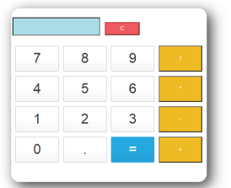

2. Student Registration Form with Input Validation using HTML, CSS and JavaScript
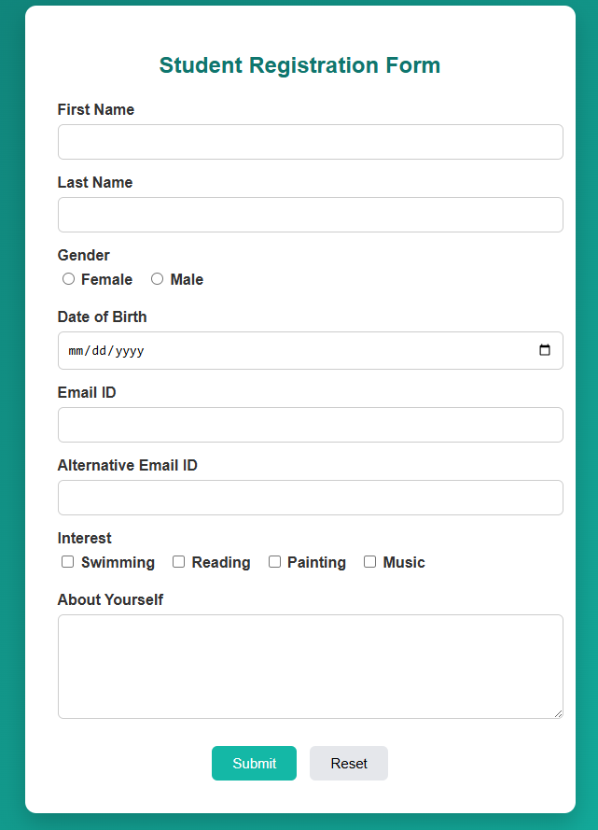

3) Fetch Data from an API Using the Fetch API in JavaScript.

